ANDROID DEVELOPMENT END SEM LAB EXAM

QUESTION 11:

Create a tictactoe app

**Mainactivity.java code:**

<manifest xmlns:android="http://schemas.android.com/apk/res/android"  
 package="com.example.tictactoe">  
  
 <application  
 android:allowBackup="true"  
 android:icon="@mipmap/ic_launcher"  
 android:label="@string/app_name"  
 android:roundIcon="@mipmap/ic_launcher_round"  
 android:supportsRtl="true"  
 android:theme="@style/Theme.AppCompat.Light.NoActionBar">  
  
 <activity android:name=".MainActivity"  
 android:exported="true">  
 <intent-filter>  
 <action android:name="android.intent.action.MAIN" />  
 <category android:name="android.intent.category.LAUNCHER" />  
 </intent-filter>  
 </activity>  
  
 <activity android:name=".ResultsActivity"  
 android:exported="true"/>  
 </application>  
</manifest>

**Activity_results.xml**

<?xml version="1.0" encoding="utf-8"?>  
<LinearLayout xmlns:android="http://schemas.android.com/apk/res/android"  
 android:layout_width="match_parent"  
 android:layout_height="match_parent"  
 android:orientation="vertical"  
 android:gravity="center">  
  
 <TextView  
 android:id="@+id/resultTextView"  
 android:layout_width="wrap_content"  
 android:layout_height="wrap_content"  
 android:textSize="24sp"  
 android:textStyle="bold"/>  
</LinearLayout>

**Styles.xml**

<resources>  
  
 <!-- Base application theme -->  
 <style name="Theme.TicTacToe" parent="Theme.MaterialComponents.Light.NoActionBar">  
 <item name="colorPrimary">#6200EE</item>  
 <item name="colorPrimaryVariant">#3700B3</item>  
 <item name="colorOnPrimary">#FFFFFF</item>  
 <item name="colorSecondary">#03DAC5</item>  
 <item name="colorOnSecondary">#000000</item>  
 </style>  
  
 <style name="TicTacToeButton">  
 <item name="android:layout_width">0dp</item>  
 <item name="android:layout_height">0dp</item>  
 <item name="android:layout_rowWeight">1</item>  
 <item name="android:layout_columnWeight">1</item>  
 <item name="android:textSize">30sp</item>  
 </style>  
  
</resources>

**Activity_main.xml**

<?xml version="1.0" encoding="utf-8"?>  
<LinearLayout xmlns:android="http://schemas.android.com/apk/res/android"  
 android:layout_width="match_parent"  
 android:layout_height="match_parent"  
 android:orientation="vertical"  
 android:gravity="center">  
  
 <ImageView  
 android:id="@+id/imageViewLogo"  
 android:layout_width="wrap_content"  
 android:layout_height="wrap_content"  
 android:src="@drawable/logo" />  
 <EditText  
 android:id="@+id/editTextName"  
 android:layout_width="match_parent"  
 android:layout_height="wrap_content"  
 android:hint="N VISHWANATHAM " />  
  
  
 <EditText  
 android:id="@+id/editTextRegistrationNumber"  
 android:layout_width="match_parent"  
 android:layout_height="wrap_content"  
 android:hint="CYS 21049"  
 android:inputType="text" />  
 <GridLayout  
 android:layout_width="wrap_content"  
 android:layout_height="wrap_content"  
 android:rowCount="3"  
 android:columnCount="3">  
  
  
 <!-- Buttons for the Tic Tac Toe grid -->  
 <Button  
 android:id="@+id/button00"  
 android:layout_width="100dp"  
 android:layout_height="100dp"  
 android:textSize="24sp"/>  
 <Button  
 android:id="@+id/button01"  
 android:layout_width="100dp"  
 android:layout_height="100dp"  
 android:textSize="24sp"/>  
 <Button  
 android:id="@+id/button02"  
 android:layout_width="100dp"  
 android:layout_height="100dp"  
 android:textSize="24sp"/>  
 <Button  
 android:id="@+id/button10"  
 android:layout_width="100dp"  
 android:layout_height="100dp"  
 android:textSize="24sp"/>  
 <Button  
 android:id="@+id/button11"  
 android:layout_width="100dp"  
 android:layout_height="100dp"  
 android:textSize="24sp"/>  
 <Button  
 android:id="@+id/button12"  
 android:layout_width="100dp"  
 android:layout_height="100dp"  
 android:textSize="24sp"/>  
 <Button  
 android:id="@+id/button20"  
 android:layout_width="100dp"  
 android:layout_height="100dp"  
 android:textSize="24sp"/>  
 <Button  
 android:id="@+id/button21"  
 android:layout_width="100dp"  
 android:layout_height="100dp"  
 android:textSize="24sp"/>  
 <Button  
 android:id="@+id/button22"  
 android:layout_width="100dp"  
 android:layout_height="100dp"  
 android:textSize="24sp"/>  
  
  
 </GridLayout>  
</LinearLayout>

**ResultsActivity.java**

package com.example.tictactoe;  
  
import android.os.Bundle;  
import android.widget.TextView;  
  
import androidx.appcompat.app.AppCompatActivity;  
  
public class ResultsActivity extends AppCompatActivity {  
  
 @Override  
 protected void onCreate(Bundle savedInstanceState) {  
 super.onCreate(savedInstanceState);  
 setContentView(R.layout.*activity_results*);  
  
 TextView resultTextView = findViewById(R.id.*resultTextView*);  
  
 // Get the result from the intent  
 String result = getIntent().getStringExtra("RESULT");  
 resultTextView.setText("Result: " + result); // Display result  
 }  
}

**AndroidManifest.xml**

<manifest xmlns:android="http://schemas.android.com/apk/res/android"  
 package="com.example.tictactoe">  
  
 <application  
 android:allowBackup="true"  
 android:icon="@mipmap/ic_launcher"  
 android:label="@string/app_name"  
 android:roundIcon="@mipmap/ic_launcher_round"  
 android:supportsRtl="true"  
 android:theme="@style/Theme.AppCompat.Light.NoActionBar">  
  
 <activity android:name=".MainActivity"  
 android:exported="true">  
 <intent-filter>  
 <action android:name="android.intent.action.MAIN" />  
 <category android:name="android.intent.category.LAUNCHER" />  
 </intent-filter>  
 </activity>  
  
 <activity android:name=".ResultsActivity"  
 android:exported="true"/>  
 </application>  
</manifest>

Output of the code :

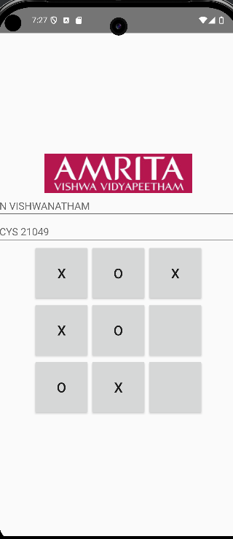

Winner will be displayed in other page:

